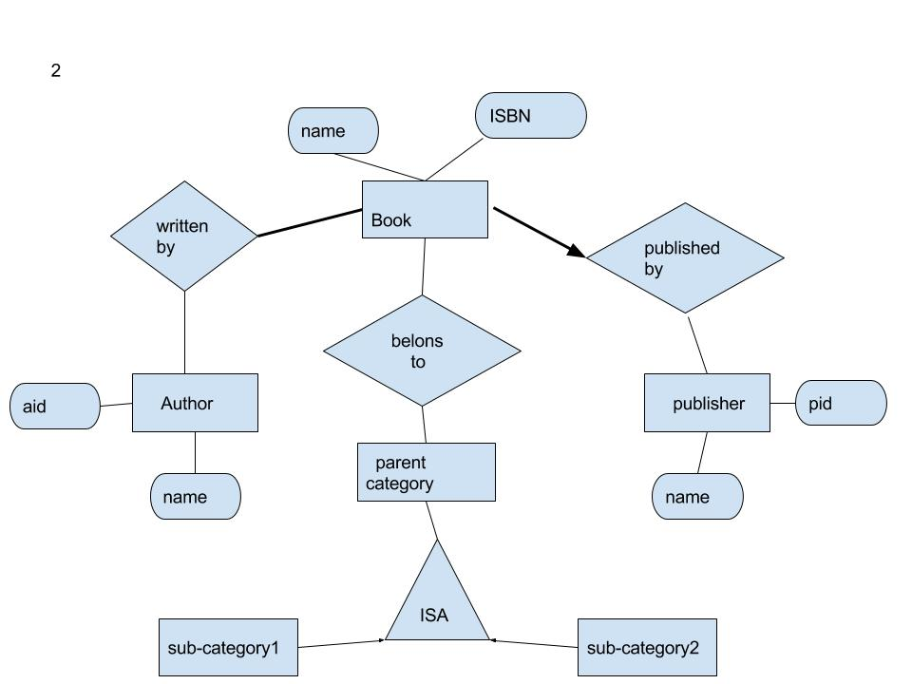

2

CREATE TABLE Book(name char(30),

ISBN char(30),

Author char(100) NOT NULL,

Publisher char(100)NOT NULL,

Category char(100),

PRIMARY KEY(name),

FOREIGN KEY(Author)REFERENCES Author,

FOREIGN KEY(Publisher)REFERENCES Publisher,

FOREIGN KEY(Category)REFERENCES Category)

CREATE TABLE Author (name char(30),

aid char(20),

PRIMARY KEY(aid))

CREATE TABLE Publisher (name char(30),

pid char(20),

PRIMARY KEY(pid))

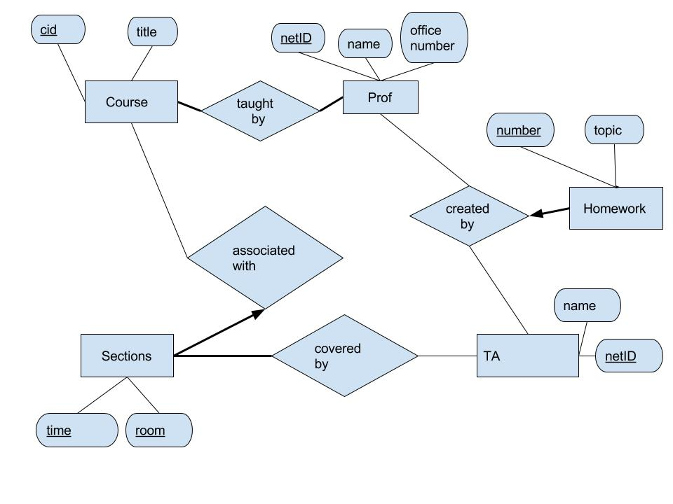

3. CREATE TABLE Course (cid char(20),

title char(30),

teacher char(30)NOT NULL,

PRIMARY KEY(cid),

FOREIGN KEY(teacher)REFERENCES Prof)

CREATE TABLE Prof( name char(30),

netID char(20),

office number:char(20),

PRIMARY KEY(netID))

CREATE TABLE Sections(time:char(20),

room:char(20),

associated course <cid:char(20)>,

covered TA_ID:char(20),

PRIMARY KEY(time+room)

FOREIGN KEY(associated course)REFERENCES Course, ON DELETE CASCADE

FOREIGN KEY(covered TA_ID)REFERENCES TA)

CREATE TABLE TA(netID char(20),

name char(20),

PRIMARY KEY(netID))

CREATE TABLE Homework(number char(20),

Topic char(30),

Creator_TA char(20),

Creator_Prof char(20),

PRIMARY KEY(number)

FOREIGN KEY(Creator_TA)REFERENCES TA,

FOREIGN KEY(Creator_Prof)REFERENCES Prof,

ON DELETE CASCADE)

PRIMARY KEY(aid))

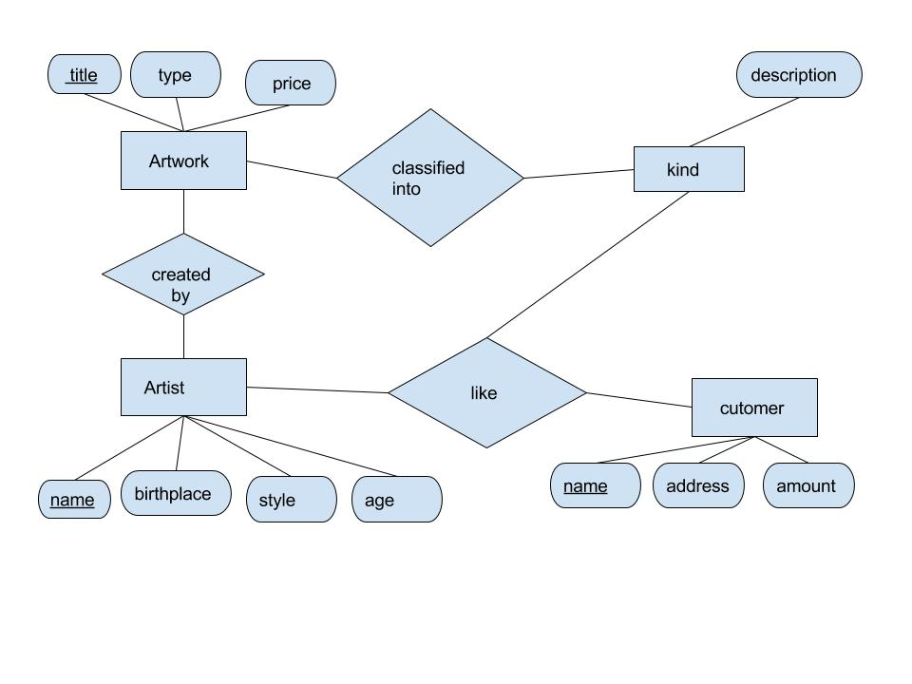

4.CREATE TABLE Artwork(title char(30),

type char(20),

price INTEGER,

creator char(20),

kind char(20),

PRIMARY KEY(title)),

FOREIGN KEY(creator) REFERENCES Artist,

FOREIGN KEY(kind) REFERENCES kind)

CREATE TABLE Artist (name char(30),

birthplace char(40),

style char(20),

age INTEGER,

PRIMARY KEY(name)

CREATE TABLE kind (description char(40),

PRIMARY KEY(description))

CREATE TABLE Customer (name char(30),

address char(30),

amount INTEGER,

like_kind char(30),

like_Artist char(30)

PRIMARY KEY(name),

FOREIGN KEY(like_kind) REFERENCES kind,

FOREIGN KEY(like_Artist)REFERENCES Aritist)